**SWR & POWER METER**

**MODEL SP-10X**

This meter is a passing power meter which is to be connected between a transceiver and an antenna and is used to measure directly transmitted power, reflected power, and SWR of the antenna system by transmitting a carrier wave.

This meter incorporates a high sensitivity, high performance power sensor, developed by WELZ, featuring flat frequency characteristics over a wide frequency range. This power sensor permits accurate measurement of power and SWR with less measurement error at any frequency band of 1.8 to 150MHZ.

**FEATURES**

1. **Compact and light-weight construction**

This meter is designed in light weight (250 g) and pocketable size, and can be applied to a variety of measurements including measurements in the open air, measurements at high location and narrow space, and measurements in a mobile car. It can be stowed conveniently in a drawer of a desk, or in the dash board compartment of a car.

1. **Accessory hand strap and magic tape**

This meter can be carried about, or hung on a projection of a pole, or attached to the dash board of a car by utilizing the accessory hand strap and magic tape.

1. **Highly accurate and highly sensitive measurement**

This meter permits highly accurate and highly sensitive measurement of HF, 50MHz (6 m), and 144MHz (2 m) bands. Its SWR measuring sensitivity is 3W (constant over 1.8 – 150MHz).

**OPERATION**

1. Connect this meter as illustrated below, and set it to the transmitting (carrier) state.

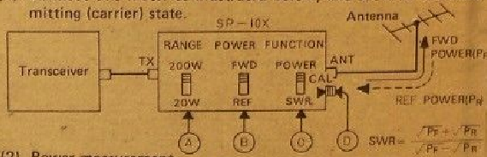

1. Power measurement

Set the selector switch (C) to the POWER position.

Set the selector switch (B) to the FWD position, and read the forward power.

Set the switch (B) to the REF position, and read the reflected power.

Change the selector switch (A) position properly according to the magnitude of the power to be measured.

1. SWR measurement

Set the selector switch to the CAL ▶ position, and turn the white knob (D) until the meter needle is aligned to the CAL ▶ position.

Then set the switch (C) to the SWR position, and read the SWR directly on the meter.

**SPECIFICATIONS**

|  |  |
| --- | --- |
| Frequency range --------------------------------- | ---------------------------------------------------------1.8 – 150MHz |
| Impedance ----------------------------------------- | --------------------------------------------------------------- 50 ohms |
| Measurable power ------------------------------- | ---------------------------------------------------------- 200 W (CW) |
| Accuracy of power measurement ------------ | -------------------------------------------------- +/- 15% of reading |
| Power measuring range ------------------------ | -------------------------------------------------------- 20 W, 200 W |
| Measuring function ------------------------------ | - Travelling-wave power/reflected wave power/V S.W.R. |
| SWR measuring power ------------------------- | ----------------------- 3 W, min. (Constant for 1.8 – 150MHz) |
| Insertion loss -------------------------------------- | ----------------------------------------------------- Less than 0.2 dB |
| Connectors ---------------------------------------- | ----------------------------------------------------------------- SO-239 |

**MADE IN JAPAN**

◀▲▼▶